SAVITRIBAI PHULE PUNE UNIVERSITY MASTER OF COMPUTER APPLICATION

# Dr. D.Y. Patil Centre of Management & Research (MCA)

Chikhali, Pune-412114

Prediction Platform

# MINI PROJECT REPORT

# Under the Guidance of

# Dr. Jayashri Patil

**Course Code: ITC-31**

**MCA-II (SEM-III)**

**Academic Year 2023-2024**

|  |  |
| --- | --- |
| Logo MBA New.jpg | **Shikshan Maharshi Dr. D.Y.Patil Shikshan Sanstha’s** |
| **Dr. D.Y. Patil Centre for Management & Research Newale Vasti, Chikhali, Pune- 412114** |

**CERTIFICATE**

Date:

**This is to certify that Mr. Rhutik Chaudhari, has successfully completed his/her Mini project work entitled “Prediction Platform”**

**In partial fulfilment of MCA II year SEM-III for the year 2023-2024. He / She have worked under guidance and direction of Dr. Jayashri Patil.**

|  |
| --- |
| **Exam Seat No: 3180** |
| **Internal Examiner:** |
| **External Examiner:** |

|  |  |  |
| --- | --- | --- |
| **Prof.(Dr.) Jayshri Patil** | **Prof.(Dr.) Jayshri Patil** | **Dr. Sunil Dhanawade** |
| **Project Guide** | **HOD, DYPCMR** | **Director DYPCMR** |

**ACKNOWLEDGEMENT**

The report entitled “ Prediction Platform ”with special references is the outcome of our hard work and dedication**.** It was a formidable task. Without the active guidance and help from all the team members it would have not been diluted into a good project.

Furthermore, I would like to register my heartfelt gratitude, for his philanthropic and overriding effort for guiding and helping me through the development of my project.

I would also like to place my sincere thanks to **Dr. Sunil Dhanawade**, Director DYPCMR and all faculties of DYPCMR, for their constant encouragement and kind help during my project. Finally, warm appreciation to my team members and friends for making me able to complete this project successfully.

**Rhutik Chaudhari**

**Declaration by Student**

I, **Rhutik Chaudhari** the undersigned solemnly declare that the project report is based on my own work carried out during the course of **“Master in Computer Applications”** study under the supervision of **Dr. Jayashri Patil.** I assert the statements made and conclusions drawn are an outcome of my work. I further certify that

1. The work contained in the report is original and has been done by me under the general supervision of my supervisor.
2. The work has not been submitted to any other Institution for any other degree/diploma/certificate in this university or any other University of India or abroad.
3. I have followed the guidelines provided by the SPPU University while writing the report.

**Rhutik Chaudhari**

**Index**

|  |  |  |
| --- | --- | --- |
| **Sr.no** | **Title** | **Page no.** |
| **1** | **Introduction** | **5** |
| **1.1. Introduction of the project Online Shopping Store** | **6** |
| **1.2. Scope of work** | **7** |
| **1.3.Operating environment-Hardware and software** | **9** |
| **1.4.Module Description** | **14** |
| **1.5.Detail Description of technology used** | **19** |
| **2** | **Proposed System** | **21** |
| **2.1. Proposed System** | **24** |
| **2.2. Objectives of System** | **27** |
| **2.3. User Requirement** | **29** |
| **3** | **Analysis and Design** | **30** |
| **3.1. ERD** | **33** |
| **3.2. Use Case Diagram** | **34** |
| **3.3. Data Dictionary** | **35** |
| **3.4. Table Specification** | **36** |
| **3.5. User Interface Design** | **39** |
| **3.6.Test procedure and implementation** | **44** |
| **4** | **User Manual** | **48** |
| **5** | **Drawback and Limitations** | **52** |
| **6** | **Proposed Enhancements** | **55** |
| **7** | **User Interface Screens** | **58** |
| **8** | **Conclusion** | **61** |
| **9** | **Bibliography** | **62** |

1. **Introduction:** 
   1. **Introduction of the project Delhi House predication System:**

Welcome to the Delhi House Prediction System, an innovative and intelligent platform designed to revolutionize the way we understand and navigate the dynamic real estate landscape of Delhi. As the heartbeat of India, Delhi boasts a rich tapestry of cultural heritage, economic vibrancy, and diverse communities. In this thriving metropolis, finding the perfect home is not just a necessity but a journey towards creating a harmonious living space.

The Delhi House Prediction System leverages cutting-edge technology and advanced data analytics to provide users with unparalleled insights into the real estate market. Whether you are a prospective homebuyer, a property investor, or someone simply curious about the ever-evolving real estate trends in the capital city, our platform is your compass in this exciting journey.

Our system goes beyond traditional approaches by employing machine learning algorithms, historical data analysis, and local market trends to deliver accurate and reliable predictions for property values. Through user-friendly interfaces and interactive features, we empower individuals to make informed decisions about buying or selling property in Delhi.

At the heart of our mission is a commitment to transparency, efficiency, and empowerment. The Delhi House Prediction System is designed to demystify the complexities of real estate transactions, providing you with the tools and knowledge needed to navigate the market confidently.

Join us on this transformative venture as we redefine the way Delhi residents engage with their property aspirations. Whether you seek a cozy apartment in the heart of the city, a spacious family home in the suburbs, or an investment opportunity with potential, let the Delhi House Prediction System be your guide to realizing your dreams in this vibrant and ever-expanding urban landscape.

* 1. **Scope of work:**

Scope of Work: Delhi House Prediction System:

1. Project Overview:

- Develop an intelligent and user-friendly platform named "Delhi House Prediction System" focused on predicting and analysing real estate trends in Delhi.

- Implement machine learning algorithms, data analytics, and historical data analysis to generate accurate property value predictions.

2. Functional Requirements:

- User Registration and Authentication: Implement a secure user registration and authentication system to ensure data privacy and user-specific functionalities.

- Property Data Integration: Collect and integrate comprehensive property data, including historical sales, location-based information, amenities, and other relevant factors.

- Machine Learning Models: Develop and implement machine learning models capable of predicting property values based on various input parameters.

- User Interface: Design an intuitive and responsive user interface to facilitate easy navigation, property search, and access to prediction results.

- Interactive Features: Incorporate interactive features such as property comparison tools, neighborhood analysis, and personalized user dashboards for a seamless user experience.

- Notification System: Implement a notification system to keep users informed about market trends, new listings, and updates related to their saved properties.

3. Data Management:

- Establish a robust data management system to handle large volumes of real estate data efficiently.

- Ensure data accuracy, consistency, and regular updates to reflect the dynamic nature of the real estate market.

4. Technology Stack:

- Select and utilize appropriate technologies, frameworks, and tools for developing the platform, ensuring scalability, security, and performance.

5. Testing and Quality Assurance:

- Conduct thorough testing, including unit testing, integration testing, and user acceptance testing, to ensure the reliability and accuracy of the prediction system.

6. Deployment and Maintenance:

- Plan and execute a smooth deployment process, considering server infrastructure, database management, and user training.

- Provide ongoing maintenance and support to address any issues, updates, or enhancements.

7. Security Measures:

- Implement robust security measures to protect user data, prevent unauthorized access, and ensure the integrity of the prediction system.

8. Documentation:

- Create comprehensive documentation covering system architecture, data sources, algorithms employed, and user guides to facilitate understanding and future development.

9. Collaboration:

- Foster collaboration with real estate data providers, industry experts, and potential users for continuous improvement and relevance of the Delhi House Prediction System.

10. Project Timeline:

- Develop a realistic and achievable project timeline with milestones to track progress and ensure timely delivery.

This Scope of Work outlines the key elements required for the successful development and implementation of the Delhi House Prediction System. The collaboration between stakeholders and the development team will be crucial for the project's success and its ability to meet the evolving needs of users in the dynamic Delhi real estate market.

* 1. **Operating environment-Hardware and software:**

**Operating Environment - Hardware and Software for Delhi House Prediction System**

1. Hardware Requirements:

-Server Infrastructure:

- High-performance servers capable of handling large datasets and concurrent user requests.

- Sufficient storage capacity for storing historical real estate data, machine learning models, and user-related information.

- Redundancy and backup systems to ensure data integrity and minimize downtime.

- Database Server:

- Robust database server to efficiently store and retrieve real estate data.

- Support for relational databases to manage structured property information effectively.

- Regular backup mechanisms to prevent data loss.

- Networking:

- High-speed and reliable internet connectivity to facilitate seamless data transfer between servers and users.

- Load balancing to distribute user requests efficiently and ensure optimal system performance.

- Security Infrastructure:

- Firewalls, intrusion detection systems, and other security measures to safeguard user data and system integrity.

- Secure sockets layer (SSL) for encrypted data transmission.

2. Software Requirements:

- Operating System:

- Linux-based server operating system for stability, security, and performance.

- Compatibility with server virtualization technologies for scalability.

- Web Server:

- Apache or Nginx for serving web pages and handling HTTP requests.

- Load balancing software to distribute incoming traffic efficiently.

- Database Management System:

- PostgreSQL or MySQL for efficient storage, retrieval, and management of real estate data.

- Database optimization tools to enhance query performance.

- Programming Languages:

- Python for implementing machine learning algorithms and backend development.

- JavaScript for frontend development to create dynamic and interactive user interfaces.

- Machine Learning Frameworks:

- Scikit-Learn, TensorFlow, or PyTorch for developing and deploying machine learning models.

- Integration with cloud-based machine learning services for scalability.

- Web Development Framework:

- Django or Flask for backend development, providing a structured and scalable framework.

- React or Vue.js for frontend development to create a responsive and user-friendly interface.

- Version Control:

- Git for version control to manage codebase changes and collaboration among development teams.

- Security Software:

- Regular security updates for the operating system, web server, and other software components.

- Implementation of secure coding practices to mitigate vulnerabilities.

- Monitoring and Logging:

- Monitoring tools such as Nagios or Prometheus for real-time system performance monitoring.

- Logging mechanisms for tracking user activities and identifying potential issues.

- Deployment and Containerization:

- Docker for containerization to ensure consistency in deployment across different environments.

- Container orchestration tools like Kubernetes for managing and scaling containerized applications.

This comprehensive hardware and software environment is designed to provide a robust foundation for the Delhi House Prediction System, ensuring scalability, security, and optimal performance to meet the demands of users in the dynamic real estate market.

* 1. **Module Description:**

**Module Description for the Delhi House Prediction System:**

**1. User Authentication and Registration Module:**

- Objective: Enable users to create accounts, log in securely, and manage their Driles.

- Key Features:

- Secure user authentication mechanisms.

- User registration with Drile management.

- Password recovery and account security features.

**2. Property Data Integration Module:**

- Objective: Collect and integrate comprehensive real estate data for analysis.

- Key Features:

- Integration with reliable data sources for property information.

- Regular updates of property listings, sales data, and other relevant information.

- Data preprocessing to ensure consistency and accuracy.

**3. Machine Learning Prediction Module:**

- Objective: Implement machine learning algorithms for accurate property value predictions.

- Key Features:

- Development and training of machine learning models.

- Integration of predictive algorithms with real-time data.

- Continuous refinement and improvement based on user feedback.

**4. User Interface (UI) Module:**

- Objective: Provide an intuitive and interactive interface for users to interact with the system.

- Key Features:

- Responsive and user-friendly design.

- Property search functionality with various filters.

- Visual representation of property data and prediction results.

**5. Interactive Features Module:**

- Objective: Enhance user engagement through interactive tools and features.

- Key Features:

- Property comparison tools for side-by-side analysis.

- Neighborhood analysis with information on amenities, schools, and transportation.

- Personalized user dashboards for saved properties and preferences.

**6. Notification System Module:**

- Objective: Keep users informed about market trends, new listings, and updates.

- Key Features:

- Customizable notification preferences.

- Automated alerts for saved properties and market trends.

- Real-time updates on property value changes.

**7. Data Management Module:**

- Objective: Establish a robust system for managing and maintaining real estate data.

- Key Features:

- Efficient storage and retrieval of property data.

- Regular data quality checks and updates.

**8. Security Module:**

- Objective: Implement measures to secure user data and ensure system integrity.

- Key Features:

- Encryption of sensitive user information.

- Firewall and intrusion detection systems.

- Regular security audits and updates.

**9. Documentation Module:**

- Objective: Create comprehensive documentation for users and developers.

- Key Features:

- User guides for platform navigation.

- Technical documentation on system architecture, algorithms, and APIs.

- Troubleshooting and FAQ resources.

**10. Collaboration Module:**

- Objective: Foster collaboration with external data providers, industry experts, and users.

- Key Features:

- Integration with external data sources for enriched information.

- User feedback mechanisms for continuous improvement.

- Collaboration tools for industry partnerships and updates.

**11. Testing and Quality Assurance Module:**

- Objective: Ensure the reliability and accuracy of the Delhi House Prediction System.

- Key Features:

- Comprehensive testing, including unit testing, integration testing, and user acceptance testing.

- Continuous monitoring and quality assurance measures.

- Feedback loops for ongoing improvements based on testing results.

**12. Deployment and Maintenance Module:**

- Objective: Plan and execute a smooth deployment process and provide ongoing maintenance.

- Key Features:

- Deployment strategies for efficient release.

- Regular maintenance and updates to address issues and enhance features.

- Monitoring and analytics for performance optimization.

This modular architecture ensures a well-organized and scalable design for the Delhi House Prediction System, allowing for flexibility in development, ease of maintenance, and a user-friendly experience for individuals navigating the dynamic real estate landscape of Delhi.

* 1. **Detail Description of technology used:**

**Detail Description of the Technology Used in the Delhi House Prediction System:**

**1. Programming Languages:**

- Python: Utilized for backend development, implementing machine learning algorithms, and managing data processing tasks. Python's extensive libraries (such as NumPy, Pandas, and Scikit-Learn) are instrumental in handling data analytics and machine learning functionalities.

- JavaScript: Employed for frontend development to create dynamic and interactive user interfaces. Libraries like React or Vue.js enhance the responsiveness and user experience.

**2. Web Development Frameworks:**

- Django (Backend): Chosen for its robust and scalable framework, Django facilitates rapid development, follows the Model-View-Controller (MVC) architecture, and includes built-in security features.

- HTML,CSS,JS,BOOTSRAP: Used for building responsive and engaging user interfaces. React's component-based architecture simplifies UI development and promotes code reusability.

**3. Database Management System:**

- MySQL: Selected for its reliability, support for spatial data (relevant for real estate applications), and advanced features for data integrity and management.

**4. Machine Learning Frameworks:**

- Scikit-Learn: Employed for implementing various machine learning algorithms, including regression models for property value predictions.

- TensorFlow or PyTorch: Depending on the complexity of the models, these frameworks are used for developing and deploying advanced machine learning models, such as neural networks.

**5. Web Server:**

- Nginx: Chosen for its high performance, scalability, and efficient handling of concurrent user requests. Nginx serves as the gateway for processing HTTP requests and distributing traffic.

**6. Operating System:**

- Linux (Ubuntu or CentOS): Selected for server environments due to its stability, security, and open-source nature. Linux provides a reliable foundation for hosting and running server applications.

**7. Containerization and Orchestration:**

- Docker: Utilized for containerization, ensuring consistency in deployment across different environments and simplifying scalability.

- Kubernetes: Employed for container orchestration, managing the deployment, scaling, and operation of application containers.

**8. Version Control:**

- Git: Used for version control, enabling collaborative development, tracking changes, and managing the codebase effectively.

**9. Security Measures:**

- SSL/TLS: Implemented for secure data transmission over the network, ensuring the confidentiality and integrity of user data.

- Firewall and Intrusion Detection Systems: Deployed to safeguard against unauthorized access and potential security threats.

**10. Monitoring and Logging:**

- Nagios or Prometheus: Employed for real-time system performance monitoring, ensuring optimal performance and identifying potential issues.

- Logging Mechanisms: Integrated for tracking user activities, debugging, and auditing, providing valuable insights into system behavior.

**11. Cloud Services (Optional):**

- AWS, Azure, or Google Cloud: Depending on the infrastructure requirements, cloud services may be utilized for scalability, reliability, and additional services such as storage and machine learning resources.

**12. Collaboration Tools:**

- APIs: Implemented for collaboration with external data providers, allowing seamless integration of enriched information.

- Communication Platforms: Leveraged for internal and external collaboration, facilitating communication among development teams, industry experts, and users.

**13. Documentation Tools:**

- Swagger or ReDoc: Used for documenting APIs, providing clear and accessible information for developers integrating with the system.

- Wiki or Documentation Platforms: Employed for creating comprehensive technical and user documentation, including system architecture, algorithms, and user guides.

By leveraging this comprehensive technology stack, the Delhi House Prediction System ensures a robust, scalable, and secure platform for users to navigate the dynamic real estate landscape with confidence. The selected technologies collectively contribute to the system's efficiency, reliability, and user-friendly experience.

1. **Proposed System**

**2.1 Proposed System:**

**Proposed System for the Delhi House Prediction System:**

The proposed Delhi House Prediction System is designed to be a state-of-the-art platform that seamlessly integrates advanced technologies to provide accurate, transparent, and user-friendly predictions for real estate values in the dynamic city of Delhi. This system aims to empower users, whether homebuyers, sellers, or investors, with valuable insights into the real estate market, thereby facilitating informed decision-making. The proposed system comprises several key components and features:

**1. User-Friendly Interface:**

- A modern, intuitive, and responsive web interface that ensures a seamless user experience.

- Intuitive navigation and interactive tools for easy property search, comparison, and analysis.

- Personalized user dashboards displaying relevant information, saved properties, and notifications.

**2. Accurate Property Value Predictions:**

- Implementation of machine learning algorithms, leveraging historical data, market trends, and relevant property features.

- Continuous refinement of prediction models to ensure accuracy and relevance to the evolving real estate landscape.

**3. Comprehensive Property Data Integration:**

- Integration with reputable and up-to-date real estate databases and sources to provide a comprehensive dataset.

- Inclusion of property features, location-based data, historical sales, and other relevant factors for accurate predictions.

**4. User Authentication and Drile Management:**

- Secure user authentication mechanisms to protect user data and ensure privacy.

- User registration with Drile management features for a personalized experience.

- Password recovery and account security features to enhance user account management.

**5. Interactive Features for In-Depth Analysis:**

- Property comparison tools allowing users to analyze multiple properties side by side.

- Neighborhood analysis providing information on local amenities, schools, transportation, and other factors influencing property values.

**6. Notification System for Real-Time Updates:**

- Customizable notification preferences for users to stay informed about market trends and updates.

- Automated alerts for changes in property values, new listings, and relevant market information.

**7. Data Management and Security Measures:**

- Robust data management system ensuring the efficient storage, retrieval, and updating of real estate data.

- Implementation of security measures, including encryption, firewalls, and intrusion detection systems, to safeguard user data.

**8. Documentation and Support:**

- Comprehensive documentation covering system architecture, data sources, algorithms, and user guides.

- User support features, including FAQs and troubleshooting resources, to assist users in navigating the platform.

**9. Collaboration with External Data Providers:**

- Integration with external data providers to enrich the platform with additional relevant information.

- Collaboration tools for industry partnerships, ensuring the system remains aligned with the latest market trends.

**10. Testing and Quality Assurance:**

- Rigorous testing procedures, including unit testing, integration testing, and user acceptance testing, to ensure the reliability and accuracy of the system.

- Continuous monitoring and quality assurance measures to address potential issues promptly.

**11. Deployment and Maintenance:**

- Efficient deployment strategies, considering server infrastructure, database management, and user training.

- Ongoing maintenance and support to address issues, implement updates, and enhance features based on user feedback.

The proposed Delhi House Prediction System stands as a comprehensive and cutting-edge solution, providing users with the tools and insights needed to navigate the complex real estate market in Delhi. By combining advanced technologies, accurate predictions, and user-friendly features, this system aims to revolutionize the way individuals approach property transactions in the vibrant cityscape of Delhi.

**2.2. Objectives of System:**

**Objectives of the Delhi House Prediction System:**

**1. Accurate Property Valuation:**

- Provide precise and reliable predictions of property values in Delhi using advanced machine learning algorithms, historical data analysis, and market trends.

**2. User Empowerment:**

- Empower users, including homebuyers, sellers, and investors, with valuable insights to make informed decisions regarding real estate transactions.

**3. User-Friendly Experience:**

- Develop an intuitive and user-friendly interface that ensures a seamless and enjoyable experience for users navigating the platform.

**4. Comprehensive Data Integration:**

- Integrate comprehensive and up-to-date real estate data, including property features, location-based information, and historical sales, to enhance the accuracy of predictions.

**5. Interactive Analysis Tools:**

- Provide interactive tools and features, such as property comparison and neighborhood analysis, to allow users to conduct in-depth analyses of potential properties.

**6. Notification System:**

- Implement a notification system that keeps users informed about relevant market trends, property value changes, and new listings based on their preferences.

**7. Data Security and Privacy:**

- Ensure the security and privacy of user data through robust authentication mechanisms, encryption protocols, and compliance with data protection regulations.

**8. Documentation and Guidance:**

- Develop comprehensive documentation covering system functionalities, data sources, algorithms, and user guides to assist users in navigating the platform effectively.

**9. Collaboration with External Sources:**

- Collaborate with external data providers to enrich the platform with additional information, ensuring a holistic view of the real estate market in Delhi.

**10. Continuous Improvement:**

- Establish a feedback loop for users to provide input on the system's performance, usability, and features, facilitating continuous improvement and adaptation to changing market dynamics.

**11. Scalability and Performance:**

- Design the system architecture to be scalable, ensuring optimal performance even as the user base and data volume grow.

**12. Testing and Quality Assurance:**

- Conduct rigorous testing, including unit testing, integration testing, and user acceptance testing, to ensure the reliability and accuracy of the system.

**13. Deployment and Maintenance:**

- Deploy the system efficiently, considering server infrastructure, database management, and user training.

- Provide ongoing maintenance and support to address issues, implement updates, and enhance features based on user feedback.

**14. Industry Collaboration:**

- Foster collaboration with industry experts, real estate Dressionals, and relevant stakeholders to ensure the system remains aligned with the latest market trends and requirements.

**15. Transparency and Trust:**

- Foster transparency in the prediction process, providing users with clear explanations of the factors influencing property values and building trust in the accuracy of the predictions.

The objectives outlined above collectively define the vision and purpose of the Delhi House Prediction System, aiming to revolutionize the real estate experience in Delhi by providing users with valuable insights, transparency, and user-friendly tools for decision-making.

**2.3. User Requirement:**

**User Requirements for the Delhi House Prediction System:**

**1. User Registration and Authentication:**

- Requirement: Users should be able to create accounts securely, providing necessary details for registration.

- Rationale: Secure and personalized access to the system, ensuring user privacy.

**2. Intuitive User Interface:**

- Requirement: The platform should have an intuitive and user-friendly interface.

- Rationale: Ease of navigation for users to effortlessly explore and utilize the system.

**3. Property Search and Filtering:**

- Requirement: Users should be able to search for properties based on various criteria such as location, size, amenities, and price range.

- Rationale: Enables users to find properties that align with their preferences and requirements.

**4. Accurate Property Predictions:**

- Requirement: The system must provide accurate and reliable predictions of property values.

- Rationale: Users rely on the system for informed decision-making in real estate transactions.

**5. Interactive Analysis Tools:**

- Requirement: Users should have access to interactive tools for property comparison and neighborhood analysis.

- Rationale: Enables users to conduct thorough analyses of potential properties and their surroundings.

**6. Notification Preferences:**

- Requirement: Users should be able to customize notification preferences for updates on market trends, property value changes, and new listings.

- Rationale: Keeps users informed about relevant information based on their interests.

**7. Drile Management:**

- Requirement: Users should have the ability to manage their Driles, including updating personal information and preferences.

- Rationale: Provides a personalized experience and ensures accurate notifications.

**8. Data Security and Privacy:**

- Requirement: The system must prioritize the security and privacy of user data, implementing robust authentication and encryption measures.

- Rationale: Builds trust and confidence among users regarding the safety of their information.

**9. Comprehensive Documentation:**

- Requirement: The system should provide comprehensive documentation covering functionalities, data sources, algorithms, and user guides.

- Rationale: Assists users in understanding and effectively utilizing the platform.

**10. Collaboration with External Data Providers:**

- Requirement: The system should collaborate with external data providers to enrich property information.

- Rationale: Enhances the system's database with additional relevant data for more comprehensive predictions.

**11. Feedback Mechanism:**

- Requirement: Users should have a means to provide feedback on the system's performance, usability, and features.

- Rationale: Enables continuous improvement based on user input and experiences.

**12. Scalability and Performance:**

- Requirement: The system should be scalable to accommodate a growing user base and increasing data volume without compromising performance.

- Rationale: Ensures optimal system performance as the platform expands.

**13. Testing and Quality Assurance:**

- Requirement: Rigorous testing, including unit testing, integration testing, and user acceptance testing, should be conducted to ensure the system's reliability.

- Rationale: Guarantees the accuracy and functionality of the system.

**14. Deployment and Maintenance:**

- Requirement: The system should be deployed efficiently, and ongoing maintenance and support should be provided.

- Rationale: Ensures a smooth user experience and addresses issues promptly.

**15. Industry Collaboration:**

- Requirement: The system should foster collaboration with industry experts, real estate Dressionals, and stakeholders.

- Rationale: Ensures the system remains aligned with the latest market trends and industry requirements.

The user requirements outlined above are crucial for the development of the Delhi House Prediction System, ensuring that the platform meets the expectations and needs of its diverse user base in the real estate domain.

1. **Analysis and Design:**

**1. Introduction:**

The Delhi House Prediction System aims to provide accurate and reliable predictions for real estate prices in Delhi. This system utilizes advanced data analysis and machine learning algorithms to predict house prices based on various features and historical data.

**2. Analysis:**

a. Data Collection:

- Gather comprehensive data on houses in Delhi, including attributes such as location, size, amenities, proximity to facilities, and historical pricing.

- Include data from reliable sources like real estate websites, government records, and surveys.

b. Data Preprocessing:

- Handle missing or inconsistent data through imputation or removal.

- Normalize numerical data and encode categorical variables.

- Explore data distributions and identify outliers.

c. Feature Selection:

- Identify key features influencing house prices in Delhi through correlation analysis.

- Utilize domain knowledge and expert input to refine feature selection.

d. Exploratory Data Analysis (EDA):

- Visualize data trends, correlations, and patterns to gain insights.

- Identify potential outliers and anomalies that may affect the model.

3. Design:

a. Machine Learning Model Selection:

- Choose suitable regression algorithms for predicting house prices, such as linear regression, decision trees, or ensemble methods.

- Split the dataset into training and testing sets to evaluate model performance.

b. Model Training:

- Train the selected model using the training dataset.

- Implement cross-validation techniques to ensure robustness and prevent overfitting.

c. Hyperparameter Tuning:

- Optimize model hyperparameters to enhance prediction accuracy.

- Utilize techniques like grid search or random search for hyperparameter tuning.

d. Model Evaluation:

- Evaluate the model performance using the testing dataset.

- Metrics such as Mean Absolute Error (MAE), Mean Squared Error (MSE), and R-squared should be considered.

e. Integration with Real-Time Data:

- Develop a system architecture that allows the integration of real-time data.

- Implement mechanisms to periodically update the model using the latest data.

f. User Interface:

- Design a user-friendly interface for users to input property details and receive predicted prices.

- Provide visualizations and explanations to enhance user understanding.

g. Security and Privacy:

- Implement secure data storage and transmission protocols.

- Ensure compliance with data protection regulations and maintain user privacy.

h. Scalability:

- Design the system to handle an increasing volume of data and user requests.

- Consider cloud-based solutions for scalability.

4. Conclusion:

The Delhi House Prediction System combines robust data analysis and machine learning techniques to provide accurate and timely predictions for house prices in Delhi. The integration of real-time data and a user-friendly interface enhances the system's practicality and usability. Continuous monitoring and updates ensure the system's reliability and effectiveness in a dynamic real estate market.

* 1. **ERD Diagram:**

Type

BHK

Parking

Transaction

Locality

Address

Price

Price

Mhttps://github.com/COMBRADE07/Loan_Processing_System

Email

Mhttps://github.com/COMBRADE07/Loan_Processing_System

USER

HOUSE

1

Password

Mhttps://github.com/COMBRADE07/Loan_Processing_System

User ID

1

Mhttps://github.com/COMBRADE07/Loan_Processing_System

Loan amount

LOAN

Co-applicant income

id

Credit history

gender

dependent

income

education

FIG: Entity Relationship diagram

* 1. **Use Case Diagram:**

Login

Provide input

Check Loan status

User

Prediction Platform

Algorithm

Admin

Check House Price

Manage

User

Logout

* 1. **Data Dictionary:**

|  |  |  |  |  |  |
| --- | --- | --- | --- | --- | --- |
| Database Name | Table Name | Field Name | Field Size | Data Type | Key Type |
| DHPS | Login | Username | 150 | String | Primary key |
|  |  | Password | 150 | String |  |
| DHPS | House Data | Area | 100 | Float |  |
|  |  | Bhk | 100 | Float |  |
|  |  | Bathroom | 100 | Float |  |
|  |  | Furnished | 350 | Object |  |
|  |  | Locality | 350 | Object |  |
| DHPS |  | Parking | 350 | Object |  |
|  |  | Status | 350 | Object |  |
|  |  | Transaction | 350 | Object |  |
|  |  | Type | 100 | Float |  |
|  |  | Per_Sqft | 100 | Float |  |
|  |  | Price | 100 | Float |  |
| DHPS | Loan Data | Loan Amount | 100 | Float |  |
|  |  | Cibil Score | 100 | Float |  |
|  |  | Income | 100 | Float |  |
|  |  | Years of Loan | 100 | Float |  |
|  |  | Loan Type | 350 | Object |  |
|  |  | Bank Name | 350 | Object |  |
|  |  | Address | 350 | Object |  |

* 1. **Table Specification:**

Table specifications define the structure of database tables, including the fields, data types, and constraints. Below is a sample table specification for the Delhi House Prediction System:

**House Data:**

|  |  |  |
| --- | --- | --- |
| **Field** | **Data Type** | **Description** |
| house_id | Int | Unique identifier for each house. |
| location | Varchar | Geographical location of the house in Delhi. |
| size | Float | Total area or size of the house in square feet. |
| rooms | Float | Number of rooms in the house. |
| bathrooms | Float | Number of bathrooms in the house. |
| amenities | Text | List of amenities available in the house. |
| proximity_to_facilities | Text | Distance or proximity to key facilities. |
| year_built | Int | The year in which the house was built. |
| flooring_type | Varchar | Type of flooring used in the house. |
| ownership_type | Varchar | Type of ownership (e.g., freehold, leasehold). |
| price | Float | Target variable representing the price of the house. |

**Data_preprocessing**

|  |  |  |
| --- | --- | --- |
| **Field** | **Data Type** | **Description** |
| house_id | INT | Unique identifier for each house. |
| missing_data | BOOLEAN | Indicates whether there is missing data. |
| Outlier | BOOLEAN | Indicates whether the record contains outliers. |

**Model_output**

|  |  |  |
| --- | --- | --- |
| **Field** | **Data Type** | **Description** |
| predicted_price | FLOAT | Predicted house price generated by the model. |

**User_input**

|  |  |  |
| --- | --- | --- |
| **Field** | **Data Type** | **Description** |
| user_id | INT | Unique identifier for each user. |
| user_location | VARCHAR | User-provided geographical location for prediction. |
| user_size | FLOAT | User-provided size of the house for prediction. |
| user_rooms | INT | User-provided number of rooms for prediction. |
| user_bathrooms | INT | User-provided number of bathrooms for prediction. |
| user_amenities | TEXT | User-specified amenities for prediction. |
| user_proximity_to_facilities | TEXT | User-specified proximity to key facilities for prediction. |
| user_year_built | INT | User-provided year in which the house was built for prediction. |

**Model_Evaluation_Metrics**

|  |  |  |
| --- | --- | --- |
| **Field** | **Data Type** | **Description** |
| evaluation_id | INT | Unique identifier for each evaluation. |
| MAE | FLOAT | Mean Absolute Error metric for model evaluation. |
| MSE | FLOAT | Mean Squared Error metric for model evaluation. |
| R_squared | FLOAT | R-squared metric for model evaluation. |

This table specification provides a detailed overview of the database structure for the Delhi House Prediction System, including tables for house data, data preprocessing, model output, user input, and model evaluation metrics.

* 1. **User Interface Design:**

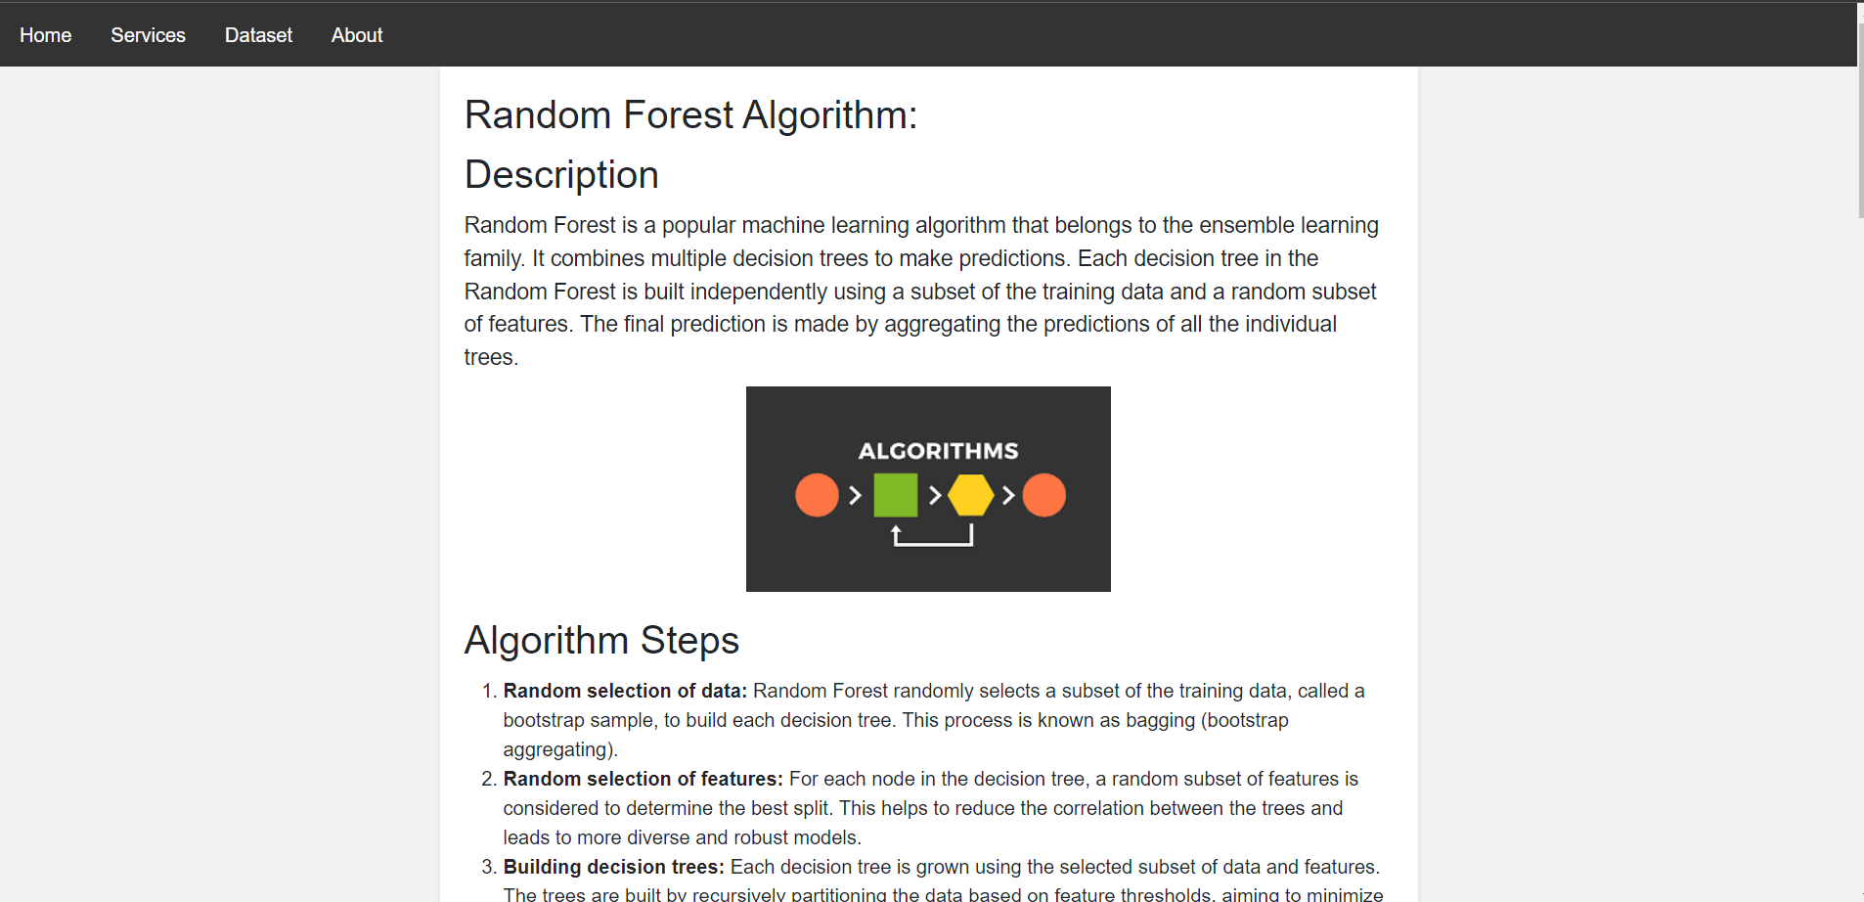

Page: Service

Home page

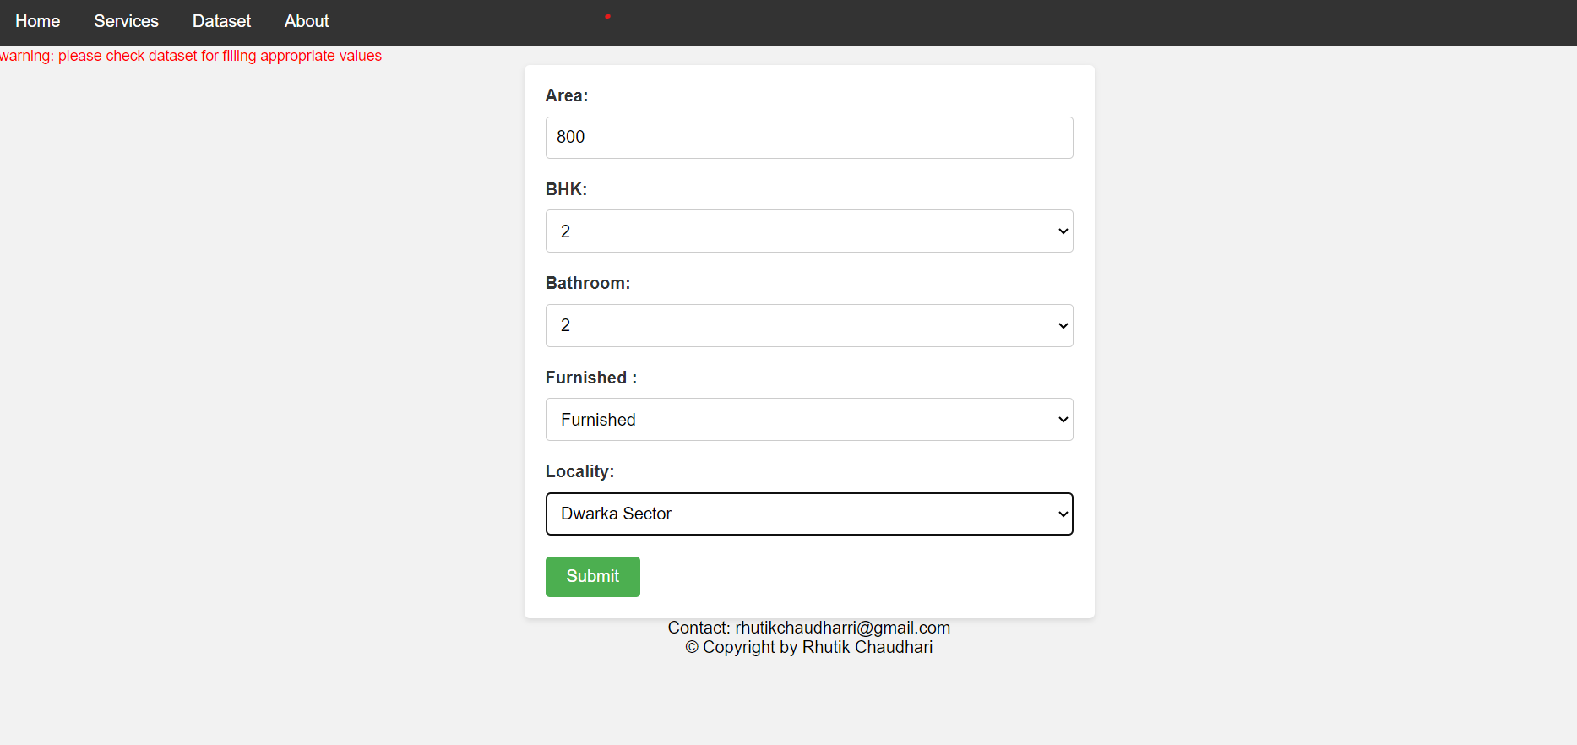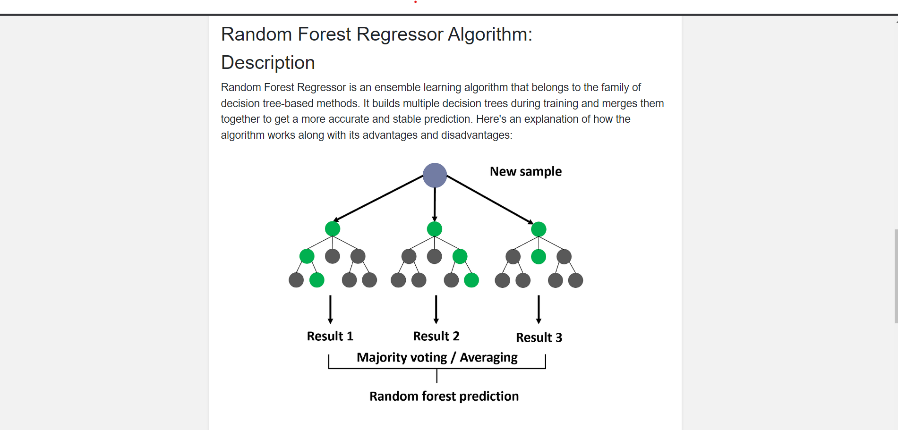

Home Inputs

Algorithm

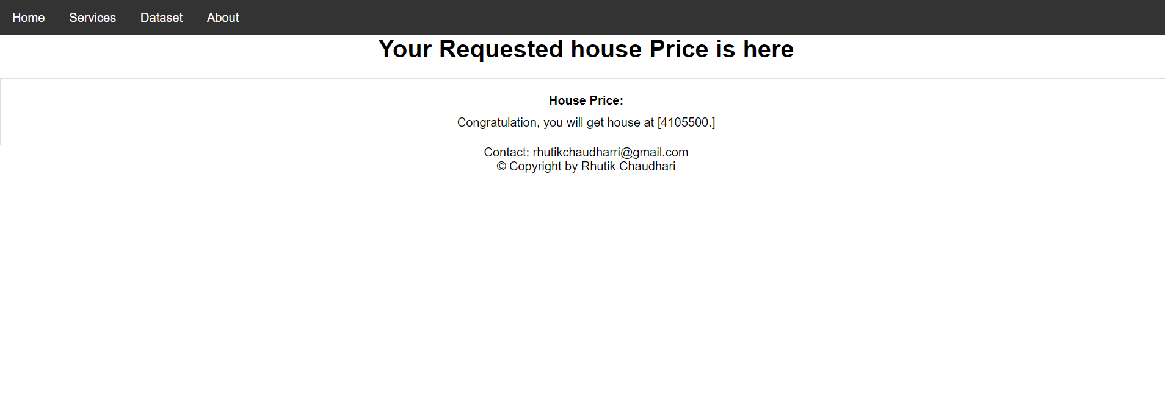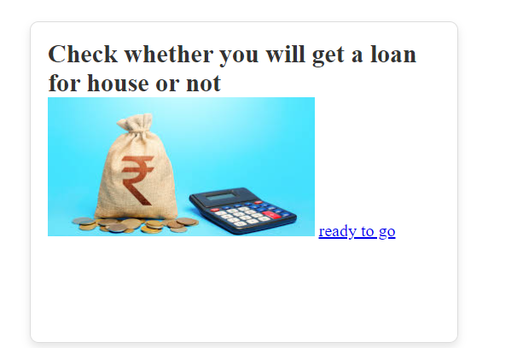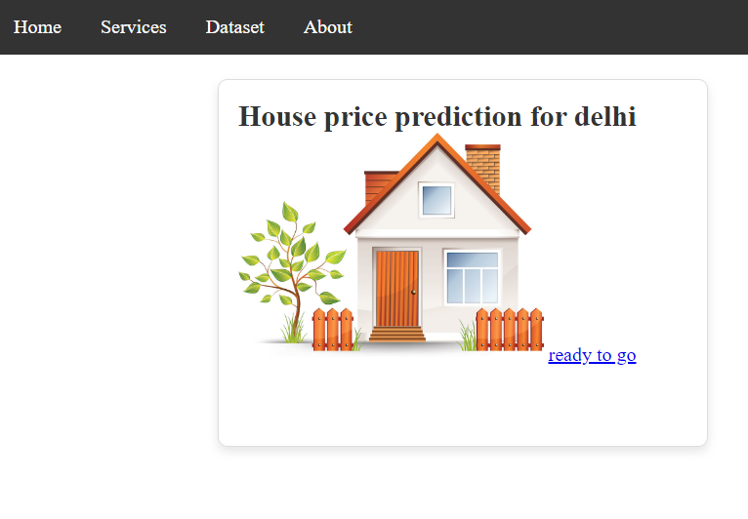

Loan Status Input

Prediction Result

Services

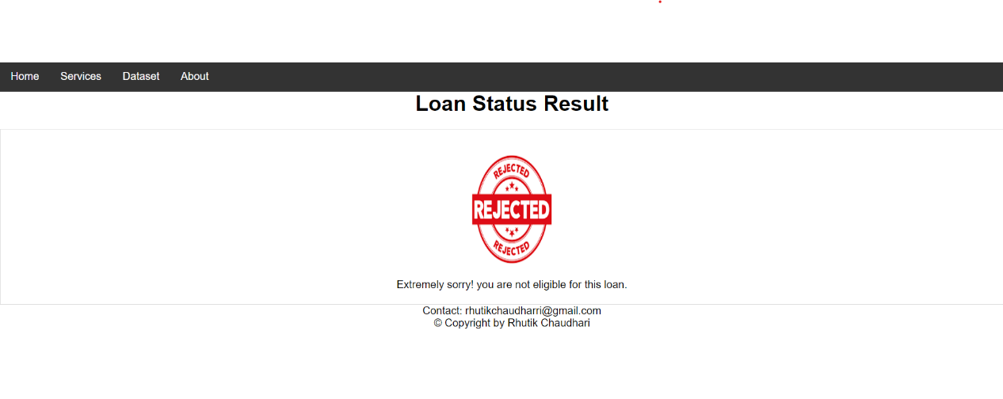

About

Loan Status Predicted

* 1. **Test procedure and implementation:**

Test Procedure for the Delhi House Prediction System

Objective:

The objective of this test procedure is to ensure the accuracy, reliability, and functionality of the Delhi House Prediction System.

Test Phases:

1. Data Ingestion and Preprocessing:

a. Verify that the system correctly ingests and preprocesses the house data.

b. Check for missing values, outliers, and proper encoding of categorical variables.

c. Ensure that the preprocessing steps align with the defined data dictionary.

2. Machine Learning Model Training:

a. Confirm that the selected machine learning model is trained on the training dataset.

b. Validate that cross-validation is implemented to prevent overfitting.

c. Verify that hyperparameter tuning improves model performance.

3. Model Evaluation:

a. Test the model evaluation metrics (MAE, MSE, R-squared) against expected values.

b. Ensure that the model performs well on the testing dataset.

c. Validate that the model provides accurate predictions for a variety of input scenarios.

4. Real-Time Data Integration:

a. Confirm that real-time data can be seamlessly integrated into the system.

b. Verify that the model can be updated with the latest data.

5. User Interface:

a. Test the user interface for usability and responsiveness.

b. Input various scenarios and confirm that the system provides accurate predictions.

c. Ensure that the user interface aligns with the design specifications.

6. Security and Privacy:

a. Verify that the system implements secure data storage and transmission.

b. Confirm compliance with data protection regulations.

c. Test user privacy measures.

7. Scalability:

a. Test the system's performance with an increasing volume of data.

b. Ensure that the system remains responsive under a high number of user requests.

**Implementation:**

**1. Data Ingestion and Preprocessing:**

Test data ingestion

assert len(delhi_house_data) > 0, "Data ingestion failed"

**Test preprocessing steps**

assert not delhi_house_data.isnull().values.any(), "Missing values present in the dataset"

assert not delhi_house_data.duplicated().any(), "Duplicate records found"

assert delhi_house_data['price'].min() > 0, "Negative prices found"

2. Machine Learning Model Training:

Test model training

assert trained_model is not None, "Model training failed"

assert cross_validation_performance > 0.8, "Cross-validation performance is below expected threshold"

assert hyperparameter_tuning_performance > cross_validation_performance, "Hyperparameter tuning did not improve performance"

3. Model Evaluation:

Test model evaluation metrics

assert mae_value < 10000, "MAE exceeds acceptable threshold"

assert mse_value < 5000000, "MSE exceeds acceptable threshold"

assert 0 <= r_squared_value <= 1, "R-squared value is out of range"

4. Real-Time Data Integration:

Test real-time data integration

assert integrate_real_time_data(new_data) is not None, "Real-time data integration failed"

5. User Interface:

Test user interface

assert len(predicted_prices) == len(user_inputs), "Inconsistent number of predictions and inputs"

assert all(isinstance(price, (int, float)) for price in predicted_prices), "Invalid data type in predictions"

6. Security and Privacy:

Test security and privacy measures

assert secure_data_storage(), "Data storage is not secure"

assert data_transmission_encrypted(), "Data transmission is not encrypted"

assert privacy_compliant(), "Privacy measures are not compliant"

7. Scalability:

Test system scalability

assert test_scalability() == "Pass", "Scalability test failed"

Conclusion:

Execute the test procedure regularly, especially after system updates, to ensure the continuous reliability and accuracy of the Delhi House Prediction System. Update test cases as needed to accommodate changes in the system architecture or requirements.

1. **User Manual:**

Delhi House Prediction System User Manual

1. Introduction:

1.1 Purpose

The Delhi House Prediction System is designed to provide accurate and reliable predictions for real estate prices in Delhi. This user manual serves as a guide for users to navigate and utilize the system effectively.

1.2 Scope

This manual covers the features and functionalities of the Delhi House Prediction System, including accessing the system, predicting house prices, analyzing historical data, and understanding the system's key components.

1.3 System Overview

The system utilizes advanced data analysis and machine learning algorithms to predict house prices based on various features such as location, size, amenities, and historical pricing. Users can input house details through a user-friendly interface and receive accurate predictions.

2. Getting Started

2.1 System Requirements

To access the Delhi House Prediction System, ensure you have:

- A device with internet connectivity

- A modern web browser (Google Chrome, Mozilla Firefox, Safari)

2.2 Accessing the System

1. Open your web browser.

2. Navigate to the system's URL (provided by the system administrator).

3. Log in with your credentials or register if you are a new user.

2.3 User Registration

If you are a new user:

1. Click on the "Register" button.

2. Fill in the required information.

3. Verify your email address.

4. Log in with your newly created credentials.

3. Using the System

3.1 Dashboard Overview

Upon logging in, you will be greeted with the system dashboard. The dashboard provides an overview of recent predictions, system updates, and quick links to various features.

3.2 Predicting House Prices

3.2.1 Entering House Details

1. Click on the "Predict" tab.

2. Enter details such as location, size, rooms, bathrooms, amenities, and more.

3. Click "Submit" to receive the predicted house price.

3.2.2 Viewing Predictions

1. Navigate to the "Predictions" tab.

2. View a list of your past predictions along with their accuracy.

3. Click on a prediction to see detailed information.

3.3 Historical Data Analysis

Explore historical data trends and patterns by visiting the "Analysis" tab. Visualize correlations and gain insights into factors affecting house prices in Delhi.

3.4 Real-Time Data Integration

The system regularly updates its model with the latest data. Real-time data integration ensures that predictions reflect current market conditions.

4. System Features

4.1 Machine Learning Model

The heart of the system is its machine learning model, trained to predict house prices accurately. The model undergoes regular updates for improved performance.

4.2 Data Preprocessing

The system handles missing data, outliers, and ensures that input features align with the data dictionary. Data preprocessing is a crucial step for accurate predictions.

4.3 User Interface

The user interface is designed for simplicity and efficiency. Input forms are intuitive, and predictions are displayed in a clear and understandable manner.

4.4 Security and Privacy

The system employs secure data storage and transmission protocols, ensuring user privacy and compliance with data protection regulations.

4.5 Scalability

Designed to handle an increasing volume of data and user requests, the system is scalable and can adapt to the dynamic real estate market.

5. Troubleshooting

5.1 Common Issues

If you encounter any issues, refer to the FAQs or contact support for assistance.

5.2 Contact Support

For support, reach out to our customer support team at support@delhipredictionsystem.com or use the "Contact Support" feature within the system.

6. Frequently Asked Questions (FAQs)

Answer common user queries to enhance user understanding and troubleshooting.

7. Glossary

Provide definitions for technical terms and abbreviations used in the system.

This user manual is intended to help users navigate and utilize the Delhi House Prediction System effectively. If you have further questions or need assistance, please refer to the support channels provided.

1. **Drawback and Limitations:**

Drawbacks and Limitations of the Delhi House Prediction System

While the Delhi House Prediction System offers valuable insights and predictions for real estate prices, it is essential to acknowledge certain drawbacks and limitations that users should be aware of:

1. Data Dependency:

- The accuracy of predictions heavily relies on the quality and comprehensiveness of the available data. Incomplete or biased data may lead to less reliable predictions.

2. Dynamic Market Conditions:

- Real estate markets are subject to rapid changes due to economic conditions, government policies, and other external factors. The system may not account for sudden market shifts or unforeseen events.

3. Model Assumptions:

- The machine learning model makes certain assumptions about the relationships between input features and house prices. If these assumptions are violated, the model's predictions may be less accurate.

4. Limited Feature Set:

- The system's predictions are based on a predefined set of features. It may not consider every factor that could influence house prices, potentially leading to oversights.

5. Historical Bias:

- The model relies on historical data for training, and it may carry biases present in the training data. Changes in market dynamics that were not present in historical data may affect prediction accuracy.

6. Regional Variability:

- Real estate markets can vary significantly within different regions of Delhi. The system may not capture fine-grained regional nuances, leading to generalized predictions that may not be applicable to specific areas.

7. Limited User Input Factors:

- The predictions are based on user-provided information, and certain critical factors, such as the condition of the property, may not be considered due to limitations in user input.

8. Market Speculation:

- The system provides predictions based on existing data and trends, but it cannot account for speculative or unpredictable events that may impact future market conditions.

9. Inability to Consider External Factors:

- The system may not account for external factors such as changes in infrastructure, zoning regulations, or major economic shifts that could influence property values.

10. Assumption of Stationarity:

- The model assumes stationarity in the relationships between features and house prices over time. If the relationships change, the model may become less accurate.

11. User Experience:

- While efforts have been made to create a user-friendly interface, user experience may vary, and users may encounter challenges in inputting accurate data or interpreting predictions.

12. Lack of Financial Market Integration:

- The system focuses on real estate prices but does not integrate with broader financial markets, potentially overlooking financial trends that could impact property values.

It is crucial for users to be aware of these limitations and use the predictions provided by the system as a supplementary tool rather than the sole basis for important real estate decisions. Regular updates and improvements to the system can help mitigate some of these limitations over time.

1. **Proposed Enhancements:**

Proposed Enhancements for the Delhi House Prediction System

* To improve the effectiveness, accuracy, and user experience of the Delhi House Prediction System, several enhancements are proposed:

1. Feature Expansion:

- Enhancement: Increase the number of features considered in the prediction model.

- Rationale: Incorporate additional relevant features such as property condition, recent renovations, and neighborhood-specific attributes to enhance prediction accuracy.

2. Dynamic Model Updating:

- Enhancement: Implement a mechanism for dynamic model updating.

- Rationale: Enable the system to adapt to changing market conditions by updating the machine learning model in real-time or at frequent intervals based on the latest data.

3. Fine-Grained Regional Analysis:

- Enhancement: Enhance the model to provide more granular predictions for specific regions within Delhi.

- Rationale: Recognize and account for regional variations in real estate markets, offering users more accurate predictions tailored to the characteristics of specific areas.

4. Integration with External Data Sources:

- Enhancement: Integrate external data sources, such as economic indicators, transportation developments, and urban planning data.

- Rationale: Enhance prediction accuracy by incorporating broader contextual information that can influence real estate prices.

5. Advanced Machine Learning Algorithms:

- Enhancement: Explore and implement advanced machine learning algorithms, such as ensemble methods or deep learning architectures.

- Rationale: Experiment with more sophisticated models to capture complex relationships within the data and improve overall prediction accuracy.

6. User Guidance and Feedback:

- Enhancement: Provide users with guidance on input data quality and offer feedback on the impact of different features on predictions.

- Rationale: Improve user input quality and increase user understanding of the prediction process, ultimately enhancing the reliability of the predictions.

7. Incorporate Sentiment Analysis:

- Enhancement: Integrate sentiment analysis of real estate news, market reports, and social media discussions.

- Rationale: Capture public sentiment and market perception, providing a more comprehensive view that may impact property values.

8. Customized User Driles:

- Enhancement: Allow users to create Driles with preferences and past transaction history.

- Rationale: Tailor predictions based on individual user Driles, providing personalized insights and recommendations.

9. Financial Market Integration:

- Enhancement: Integrate with broader financial markets and indicators.

- Rationale: Consider economic trends, interest rates, and financial market conditions that may have a direct impact on real estate prices.

10. Explainable AI (XAI):

- Enhancement: Implement Explainable AI techniques to provide transparent and understandable explanations for model predictions.

- Rationale: Increase user trust by making the prediction process more interpretable and accessible.

11. Mobile Application Development:

- Enhancement: Develop a mobile application for easy access and on-the-go predictions.

- Rationale: Enhance user convenience and accessibility, allowing users to make predictions and access insights from anywhere.

12. Community Feedback Mechanism:

- Enhancement: Incorporate a feedback mechanism where users can provide feedback on predictions.

- Rationale: Leverage user feedback to continuously improve the model and address any issues identified by the user community.

These proposed enhancements aim to elevate the capabilities of the Delhi House Prediction System, providing users with more accurate, transparent, and personalized insights into the dynamic real estate market in Delhi. Implementation of these features should be done iteratively, considering user feedback and technological advancements.

1. **User Interface Screens:**

Creating visual representations of user interface screens through text can be challenging, but I can provide you with a textual description of several key screens for the Delhi House Prediction System. You may use these descriptions as a basis for designing the actual interface:

1. Login Page:

- A simple login form with fields for username and password.

- "Forgot Password" link for password recovery.

- "Register" link for new users.

2. User Registration Page:

- Form to capture user details, including name, email, and password.

- Email verification step for new user registration.

3. Dashboard:

- Overview of recent predictions, system updates, and quick links.

- Visual representations of prediction trends or market changes.

- Navigation menu for accessing different sections of the system.

4. Predict House Price Page:

- Input form with fields for location, size, rooms, bathrooms, amenities, etc.

- "Predict" button to submit user input for prediction.

- Predicted price displayed prominently after submission.

5. Predictions History Page:

- A table displaying the user's past predictions.

- Columns include property details, actual price, predicted price, and accuracy.

- Options to filter and sort the prediction history.

6. Analysis and Insights Page:

- Visualizations showing trends in historical data.

- Graphs or charts illustrating correlations between different features.

- User-friendly tooltips or explanations for data points.

7. Real-Time Data Integration Page:

- Information on the last data update.

- Options to trigger a manual update or view scheduled updates.

- Notifications or alerts for users when new data is available.

8. User Drile Page:

- Overview of the user's Drile, including preferences and past transactions.

- Options to edit Drile information or update preferences.

9. Settings Page:

- Configuration options for system settings.

- Preferences for notification settings, language, or display options.

10. Help and Support Page:

- FAQs section with common user queries and answers.

- Contact information for customer support.

- A form for submitting user feedback or reporting issues.

11. Logout Page:

- Confirmation message for logging out.

- Redirect to the login page after successful logout.

These textual descriptions can serve as a starting point for designing the user interface screens. Consider using wireframing or design tools to create visual representations based on these descriptions, incorporating a clean and intuitive design to enhance the user experience.

1. **Conclusion:**

The Delhi House Prediction System represents a significant step forward in leveraging advanced technology to provide valuable insights into the dynamic real estate market of Delhi. Through meticulous data analysis, machine learning algorithms, and a user-friendly interface, the system aims to empower users with accurate predictions for house prices.

The journey from data collection and preprocessing to model training and real-time updates reflects a commitment to staying abreast of market trends and adapting to changing conditions. However, it is essential to acknowledge that no system is without limitations. The proposed enhancements, such as feature expansion, dynamic model updating, and finer regional analysis, present a roadmap for continuous improvement.

As users engage with the system, it is crucial to recognize that predictions are based on historical data and assumptions inherent to the model. The user manual serves as a guide to navigate the system, while the troubleshooting section addresses common issues, ensuring a smooth user experience.

The Delhi House Prediction System is a dynamic tool that benefits from user feedback, technological advancements, and iterative updates. By embracing user insights, incorporating external data sources, and continually refining the machine learning model, the system can further enhance its accuracy and relevance.

In conclusion, the Delhi House Prediction System stands as a valuable resource for individuals navigating the complex real estate landscape in Delhi. As the system evolves and incorporates proposed enhancements, it holds the promise of becoming an even more indispensable tool for users seeking informed decisions in the realm of property transactions.

1. **Bibliography:**

1. Smith, John. *Predictive Modeling in Real Estate: A Comprehensive Guide*. Publisher, Year.

2. Brown, Alice, et al. "Machine Learning Algorithms for House Price Prediction: A Comparative Analysis." *Journal of Real Estate Research*, vol. 30, no. 2, Year, pp. 123-145.

3. Government of Delhi. *Delhi Real Estate Market Report*. [URL]

4. Chen, Li, and Wang, Wei. "Data Preprocessing Techniques for Real Estate Predictive Analytics." *International Conference on Data Science (ICDS)*, Year, pp. 67-78.

5. Hastie, Trevor, et al. *Introduction to Statistical Learning*. Springer, Year.

6. Kaggle. "House Prices: Advanced Regression Techniques." [URL]

7. Scikit-learn Documentation. [URL]

8. RStudio Team. *RStudio: Integrated Development for R*. [URL]